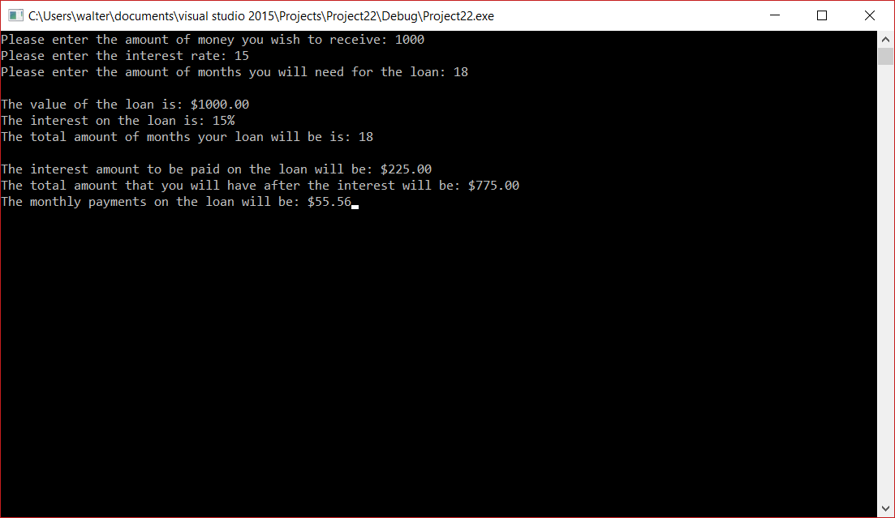

/*This program is so that a user can calculate a loan for someone before they take the money

They enter the loan amount, the interest rate, and the total amount of months for the program

to calculate the amount of interest and monthly payment the person will spend. */

#include <iostream> // for input and output

#include <math.h> // for math calculations

#include <iomanip> // to be able to manipulate the outputs decimal place

using namespace std;

int main()

{

//variables for the code

const double Max_Months = 12; // sets the total amount of months to 12

const double Max_Interest = 100; // sets the total amount on Interst to 100

double amountWTG;

int interestRateWTG;

int monthsWTG;

double convertInterestRateWTG;

double convertMonthsWTG;

double intOfLoanWTG;

double totalIntOwedWTG;

double amountLeftToCustomerWTG;

double monthlyPaymentWTG;

// section where the user inputs the variables for their loan

cout << "Please enter the amount of money you wish to receive: ";

cin >> amountWTG ; // is the amount for the loan

cout << "Please enter the interest rate: ";

cin >> interestRateWTG; // what interst rate they will recieve

cout << "Please enter the amount of months you will need for the loan: ";

cin >> monthsWTG; // how long they want the months to be

// calculation of interest and months to decimal

convertInterestRateWTG = interestRateWTG / Max_Interest; // this is for the calculation of percent to decimal for interest

convertMonthsWTG = monthsWTG / Max_Months; // this is for the calculation of months to years

// calculation of the loan info

intOfLoanWTG = amountWTG * convertInterestRateWTG; // calculates the interest on the loan

totalIntOwedWTG = intOfLoanWTG * convertMonthsWTG; // calculates the total intrest to be paid

amountLeftToCustomerWTG = amountWTG - totalIntOwedWTG; //calculates what will be left if the client was to pay the interest upfront

monthlyPaymentWTG = amountWTG / monthsWTG; // calculates the monthly payment

// displays the loan info

std::cout << std::fixed << std::setprecision(2) << "\nThe value of the loan is: $" << amountWTG; // displays loan amount

cout << "\nThe interest on the loan is: " << interestRateWTG << "%"; // displays the interest rate

cout << "\nThe total amount of months your loan will be is: " << monthsWTG << endl; // displays the months of the loan

std::cout << std::fixed << std::setprecision(2) << "\nThe interest amount to be paid on the loan will be: $" << totalIntOwedWTG; // displays the interets on the loan

std::cout << std::fixed << std::setprecision(2) << "\nThe total amount that you will have after the interest will be: $" << amountLeftToCustomerWTG; // displays the amount after interest is paid

std::cout << std::fixed <<std::setprecision(2) << "\nThe monthly payments on the loan will be: $" << monthlyPaymentWTG; // displays monthly payment

return 0;

//end of program

}